Problem: Lisa’s Workbook

Lisa just got a new math workbook. A workbook contains exercise problems, grouped into chapters.

* There are  chapters in Lisa's workbook, numbered from  to .
* The -th chapter has  problems, numbered from  to .
* Each page can hold *up to*  problems. There are no empty pages or unnecessary spaces, so only the last page of a chapter may contain fewer than  problems.
* Each new chapter starts on a new page, so a page *will never* contain problems from more than one chapter.
* The page number indexing starts at .

Lisa believes a problem to be *special* if its index (within a chapter) is the same as the page number where it's located. Given the details for Lisa's workbook, can you count its number of *special* problems?

**Note:** See the diagram in the *Explanation* section for more details.

**Input Format**

The first line contains two integers  and  — the number of chapters and the maximum number of problems per page respectively.   
The second line contains  integers , where  denotes the number of problems in the -th chapter.

**Constraints**

**Output Format**

Print the number of *special* problems in Lisa's workbook.

**Sample Input**

5 3

4 2 6 1 10

**Sample Output**

4

**Explanation**

The diagram below depicts Lisa's workbook with  chapters and a maximum of  problems per page. Special problems are outlined in red, and page numbers are in yellow squares.

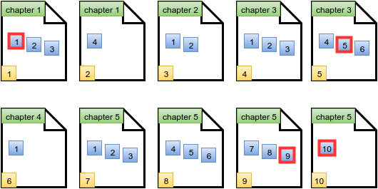

There are  special problems and thus we print the number  on a new line.

Solution

int chapters, maxP, page=1, counter=0;

cin>>chapters>>maxP; //maxP --> maximum questions per page

int array[chapters];

/*Necessary data feeding loop*/

for(int i=1; i<=chapters; i++) //runs for each chapter

{ //separately and inputs data

cin>>array[i]; //Inputs the data

int inc=0; //inc--> how many pages will be used ?

(array[i]%maxP!=0 ? inc=array[i]/maxP+1 : inc=array[i]/maxP); //value for inc

int que=1,

for(int j=page; j<page+inc; j++) //runs separately for each page of this chapter

{ //Runs per question on each page

while(que<=maxP*(j-page+1) && que<=array[i]) {

if(que==j) //page is special ?

{counter+=1;}

que++; //moves on to next page for check

}

}

page=page+inc; //updates page value

}

cout<<counter; //prints the answer

}

}

* Anshul AgGarwal